# 9 Men’s Morris Project Report

**What is 9 men’s morris?:**

It is an ancient 2 player strategy board game consisting of three concentric squares, connected by the middles of each of the inner square’s sides to the middle of the corresponding outer square’s side.

Pieces are played on the corner vertices. Meaning there are 24 playable points.

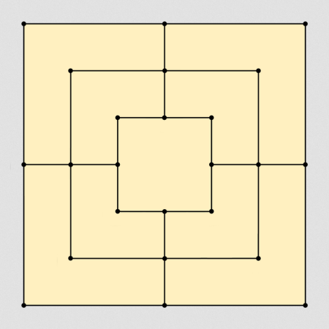

Both players try to form ‘mills’ (three of their pieces in a straight line). A mill allows them to remove an opponent piece from the game. A player wins when their opponent has only 2 pieces left, or by leaving them without any possible moves.

There are 3 phases to the game:

1. Placing pieces on vacant points (9 turns each)
2. Moving placed pieces to adjacent points.
3. Moving pieces to any vacant point (when the player has been reduced to 3 men)

**My approach:**

I have created 2 heuristics to have the AI learn how to play the game.

1. Number of Pieces: The higher the difference in the number of pieces of player 1 and player 2, the better.
2. Number of potential mills: The higher the number of mills potentially formed, the better.

Heuristic #2 performs much better than heuristic #1.

Important utility functions have been placed in utils.py and are imported by the three files used to play the game.

It can be run in 3 modes:

1. Human vs. human
2. Human vs. AI
3. AI vs AI

In the third mode, we are pitting two AIs using different heuristics against each other. The scenario runs automatically and shows us who won.